- Purpose
  - The purpose of this document is to describe the procedure for assembling a propane burnisher pad driver.
- Scope
  - This SOP applies to all equipment assembly team members. The process applies to the following sub-assembly’s:
EP50040EQS0600BE1200 – Flex lok assembly 27” complete
EP50027EQS0600BE1200 – Flex lok assembly 24” complete
EP50028EQS0600BE1200 – Flex lok assembly 21” complete
- Responsibilities
  - The operations manager/supervisor is responsible for enforcing this SOP.
- Materials
  - The proper materials needed for this process are listed on the sub-assembly work order.
  - Hand/Power Tools
  - Riveter
- Definitions

- Procedure
  - Start by bolting the shaft plate (10586) to the flex-lok (10252 for 27”, 10251 for 24”, or 10250 for 21”) using 6 bolts (10112), lock washers (81067), flat washers (12444), and nuts (81063).

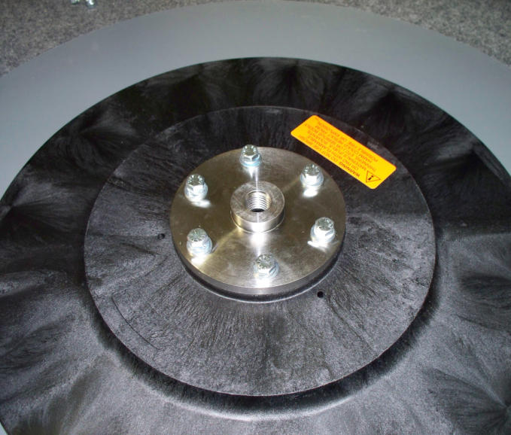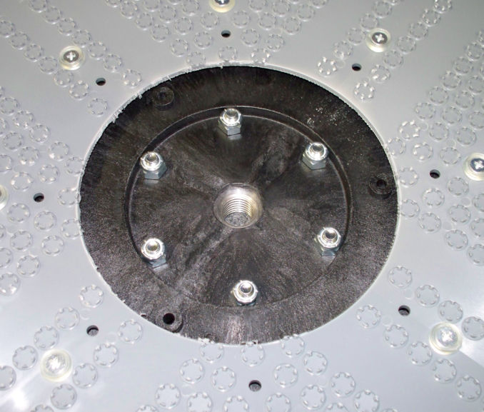
Nut
Lock Washer
Flat Washer

Flex-Lok

Nut

  - Unscrew the top and bottom pieces of the center-lock. Attach the appropriate half of the center lock (12517) to the flex-lok using 3 rivets (10850) and the pneumatic riveter. Use the three holes shown in the picture below.
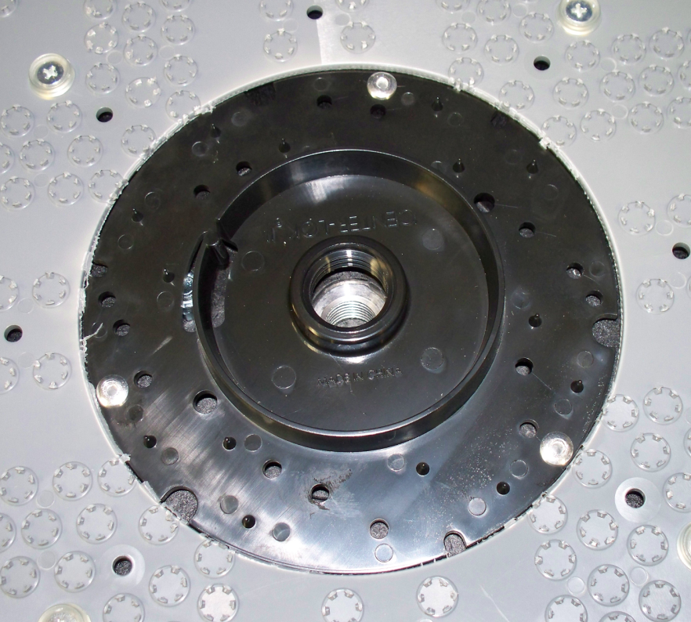
Rivet

Rivet

Rivet

Center Lock

  - Place a burnishing pad (84627 for 27”, 84624 for 24”, or 84621 for 21”) onto the gripping side of the flex-lok. Center the pad as best as possible.
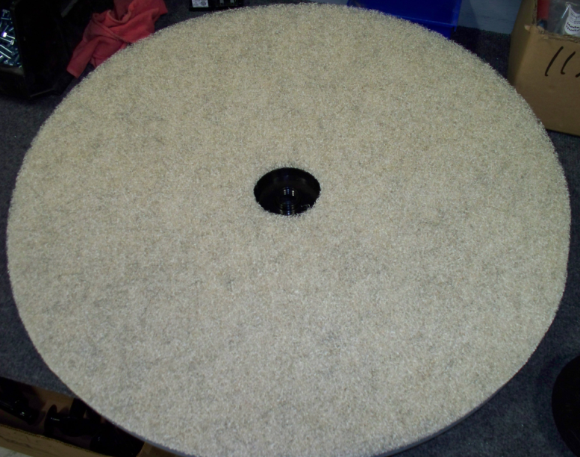
Burnishing Pad
  - Thread the remaining half of the center lock into the center of the pad driver. Thread it until the 2 halves start to ratchet together.
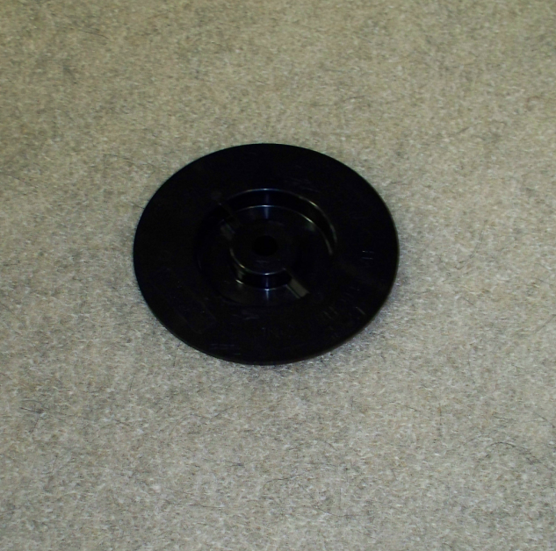
Center-Lock

- References (optional section as needed)

- Training Guide

Functional Training Groups Requiring Training
Equipment Assembly Group

- SOP Change Control

Date of Change | Reason for Change
Rev 01 - 11/18/2013 | This is the first version of the S.O.P. hence there are no revisions to this document.
Rev 02 - 1/12/2018 | Added the Responsibilities section
Rev 03 - 3/21/2025 | Removed work center note

Approvals

Submitter/Author Approval:__________________________________ Date:______________________

Management Approval:______________________________________ Date:______________________

QAU Approval:_____________________________________________ Date:______________________

